**STEP 1: Set Up GitHub Repository**

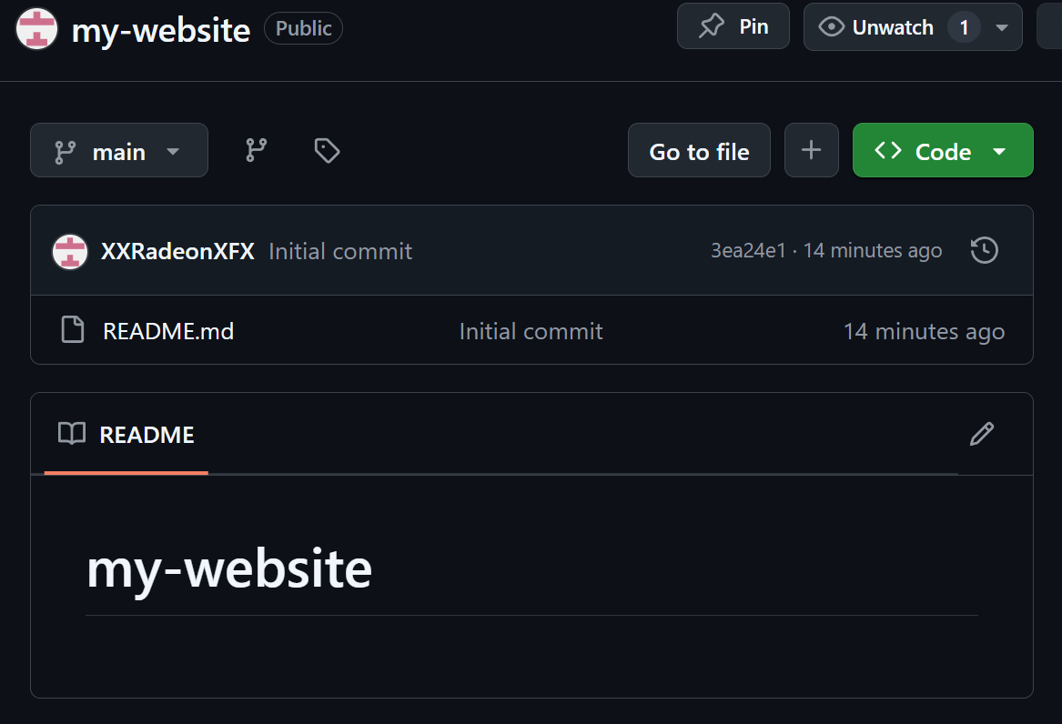

**STEP 2: Prepare Your Linux Server or VM**

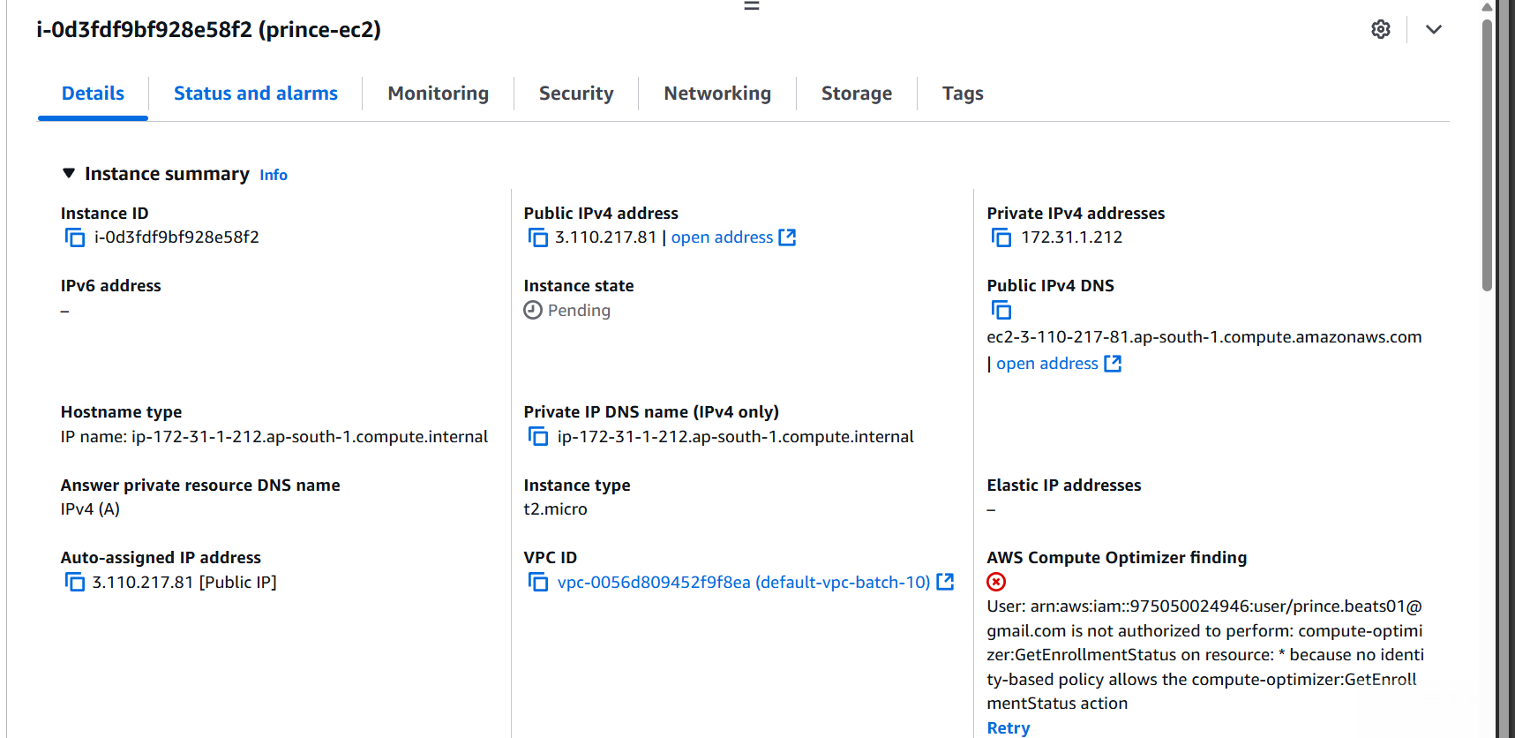

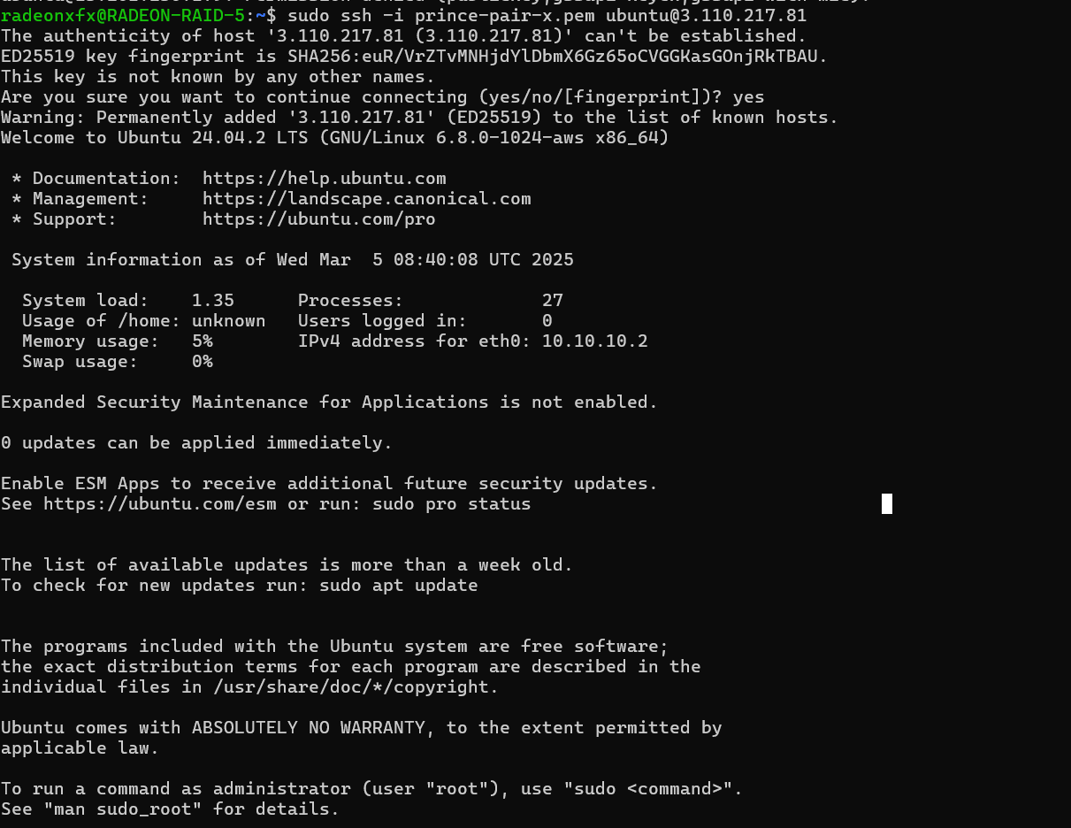

**STEP 3: Install Required Tools on the Server**

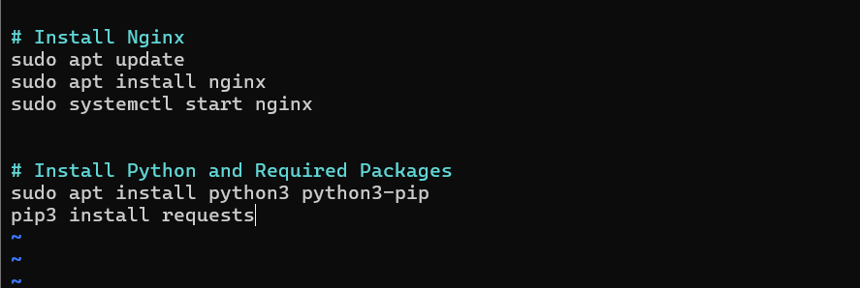

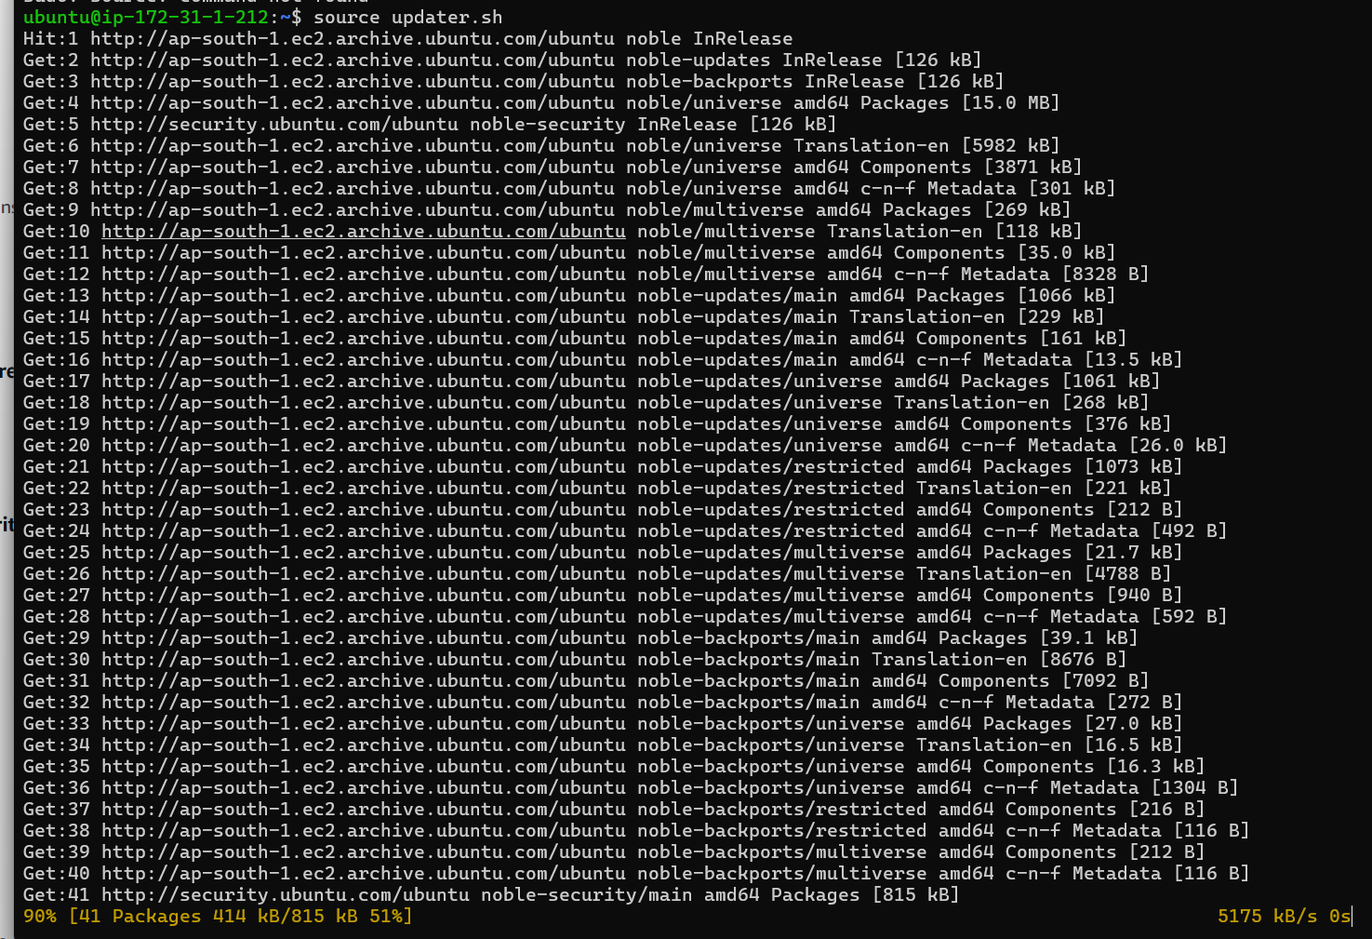

**STEP 4: Creating a Python Commit checker Script**

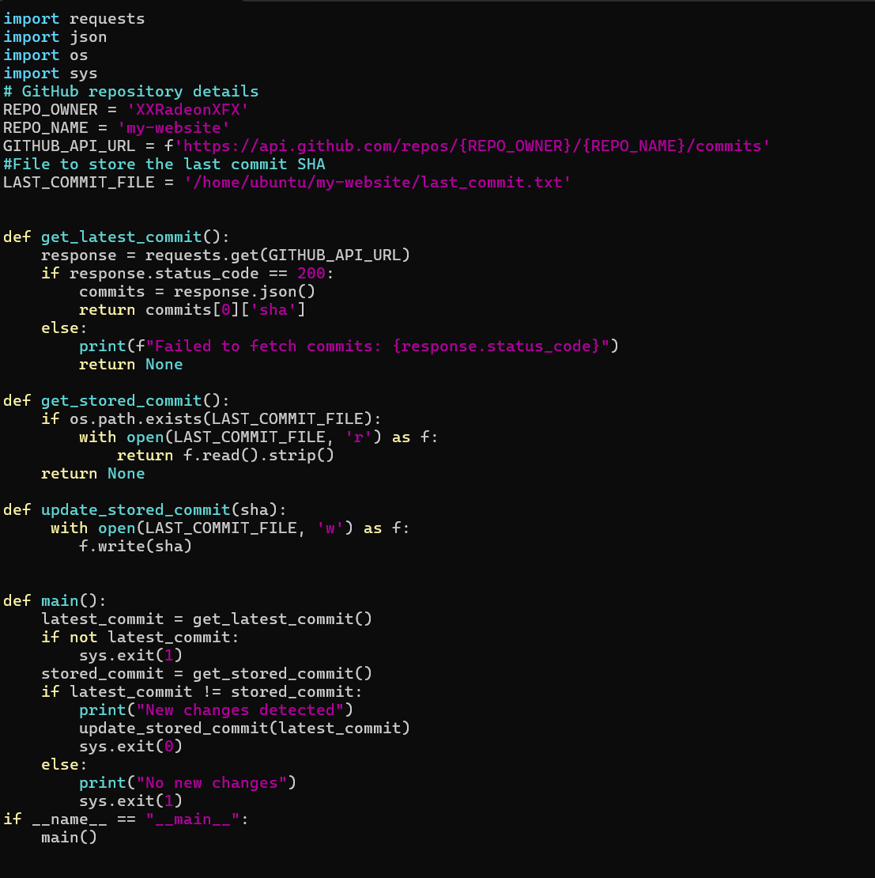

**STEP 5: Update Nginx Root Directory**

**sudo nano /etc/nginx/sites-available/default**

* **then change root folder value**

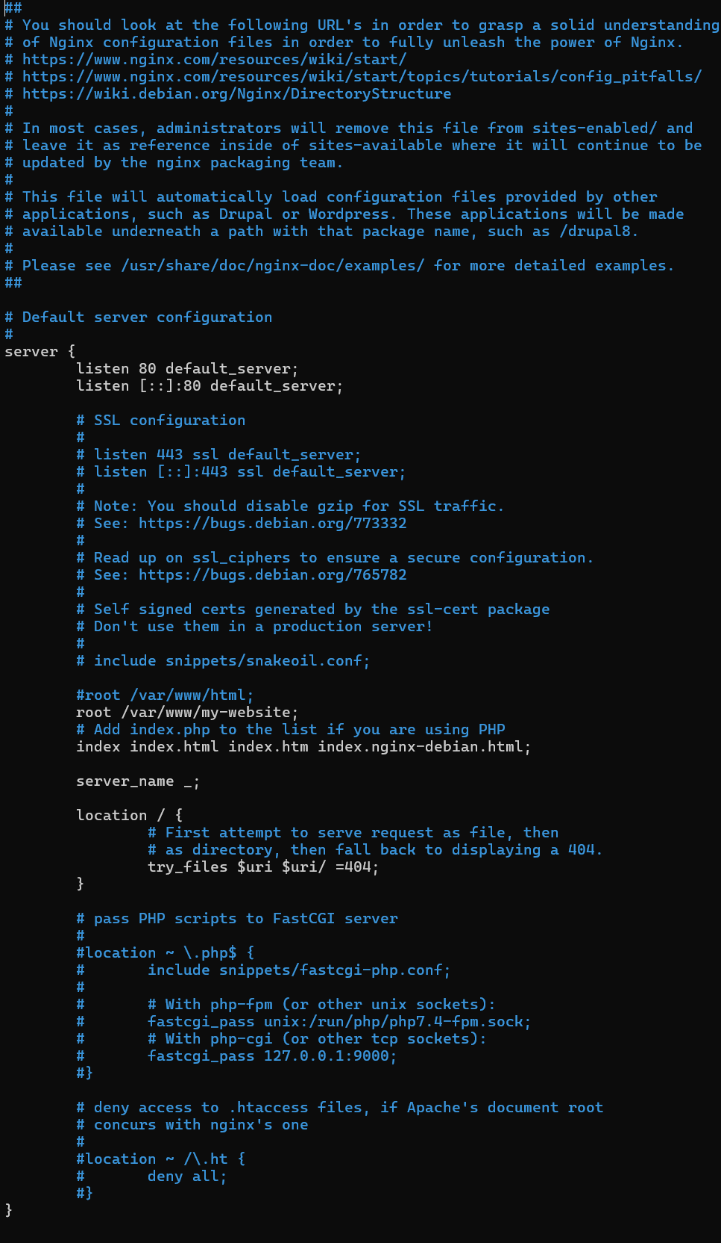

**STEP 6: Adding bash script that updates /var/www/my-website PATH**

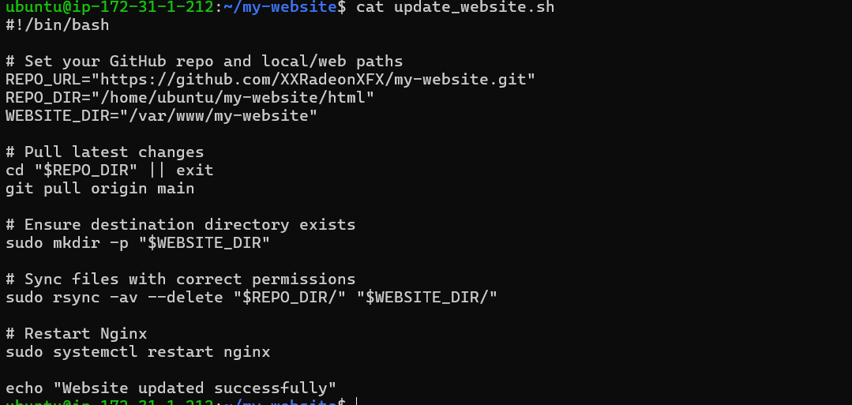

**Make it executable:**

**sudo chmod +x** **update_website.sh**

**STEP 6: Wrapper Script and Cron Job Setup:**

This script:

* Runs our Python script to check for changes If there are changes,
* it runs our Bash script to update the website Save this as ci_cd_wrapper.sh on your server

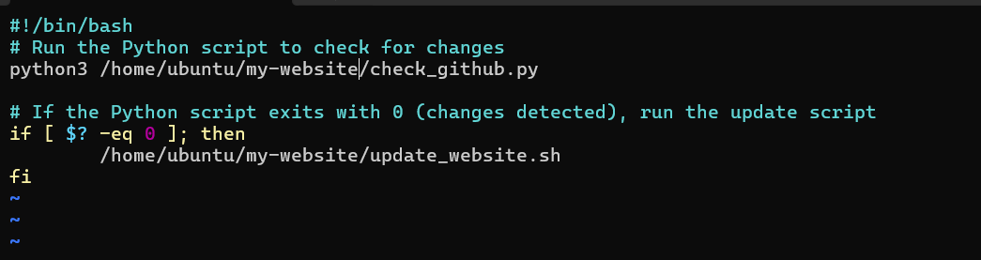

**Make it executable:**

**sudo chmod +x ci_cd_wrapper.sh**

**STEP 7: Schedule with Cron Job for every 5 mins**

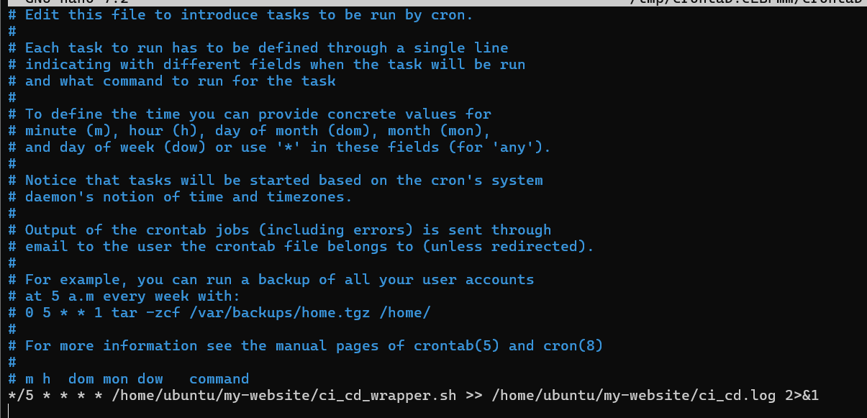

**STEP 7: Test the Pipeline**

1. **update index.html inside html folder :**

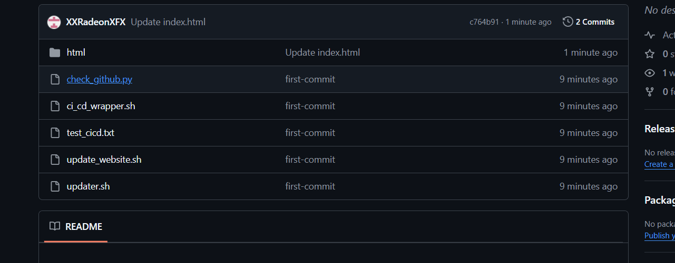

1. **Do a git pull inside EC2 and use command [ tail -f ci_cd.log ]**

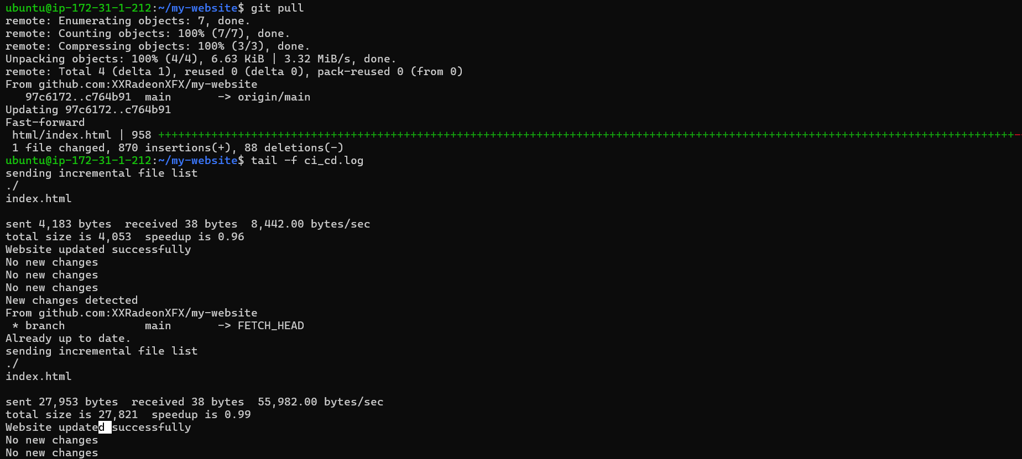

1. **Visit the EC2 public ip**

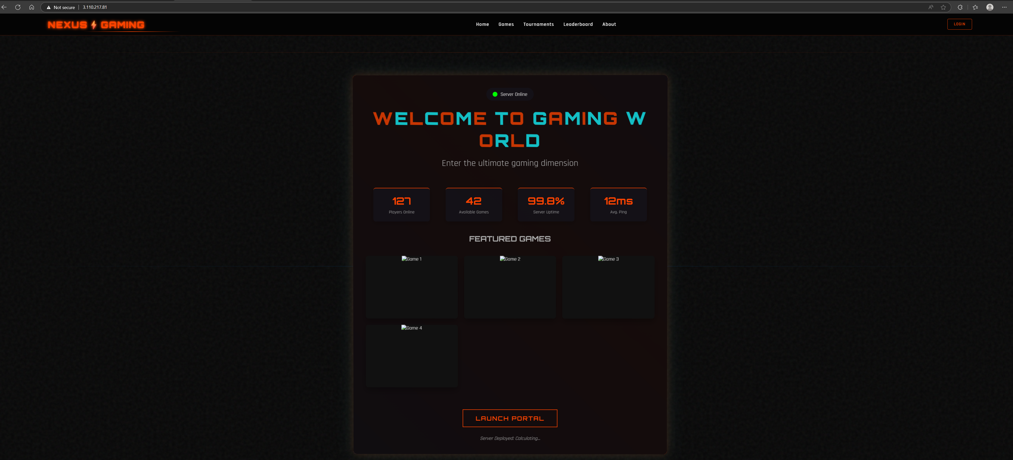

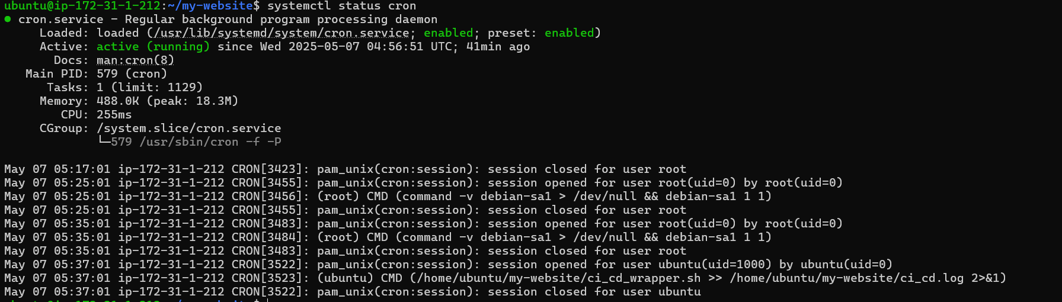

**# Important Command to remember:  
sudo nano /etc/nginx/sites-available/default**

**systemctl status cron**

**grep CRON /var/log/syslog**